# Redux in React

## Basic

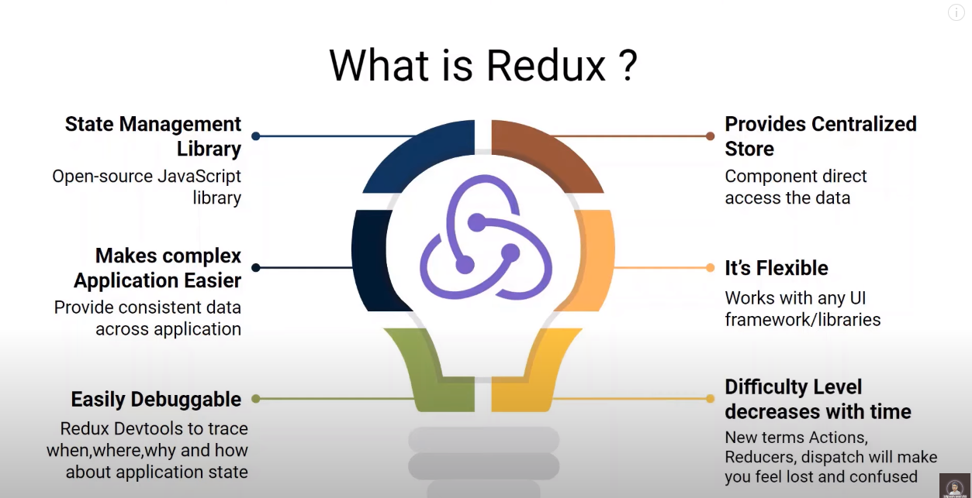

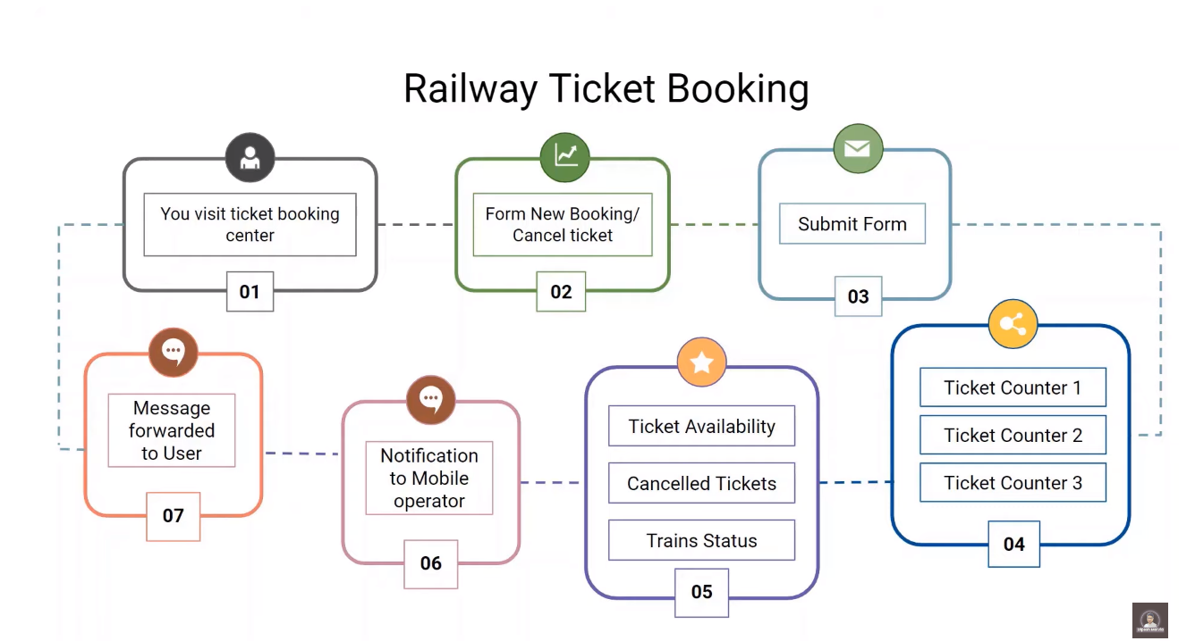

## Setup

npm install redux react-redux

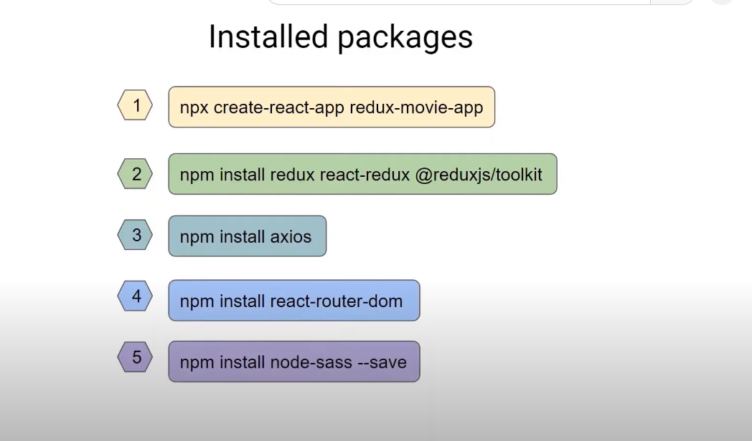

npm i redux react-redux @reduxjs/toolkit

npm i axios

npm i react-router-dom

npm i node-sass --save